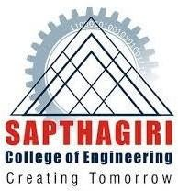
SAPTHAGIRI COLLEGE OF ENGINEERING
BENGALURU-560057
Affiliated to VTU, Belagavi and approved by AICTE, New Delhi Accredited by NAAC with “A” grade, Accredited by NBA for ECE, CSE, ISE, ME, EEE
An ISO 9001:2015 & ISO 14001:2015 Certified Institution
Department of Civil Engineering
SOLID WASTE MANAGEMENT (BCV515C)
1ST SET ASSIGNMENT QUESTIONS
MODULE 1
- Explain the source and engineering classification of solid waste.
- Explain the need of solid waste management.
- List out the policies and frame works taken by government or central government for solid waste management for & explain anyone.
- Explain the concept of 3R.
- Explain the steps involved in management of integrated solid waste.
- Explain briefly the environmental friendly approaches used to reduce the impact due to solid waste.
MODULE 2
- Explain different factors affecting waste generation.
- Explain physical characteristics of solid waste.
- Discuss on the method of calculating waste generation.
- Explain chemical & biological characteristics of solid waste.

